**ABU LIBRARY COMPLEX BULLETIN BULLETIN**

**SPECIAL BULLETIN VOLUME: Vol. 4 No. 2 MONDAY, 27TH Feb. 2017**

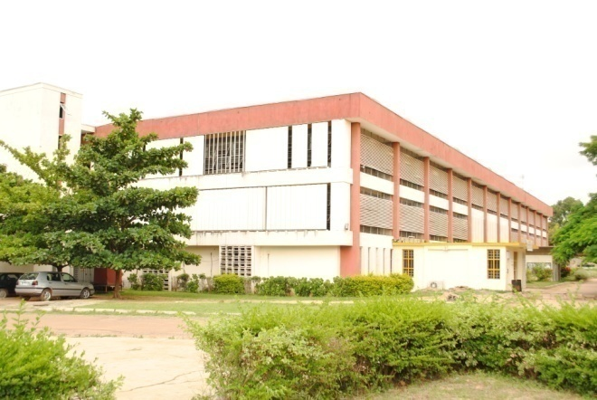

**ELSEVIER EBOOKS AND ACADEMIC DEVELOPMENT IN ABU**

Elsevier is an academic publishing company which publishes medical and scientific literature. Elsevier publishes 250,000 articles a year in 2,000 journals. Its archives contain seven million publications. Total yearly downloads amount to 240 million.

Today there are more than 7 million researchers working in thousands of institutions across hundreds of fields of study all of them looking to make their mark and build a reputation. To that end, researchers must continuously conduct and publish their findings. It is an established fact that peer-reviewed article is the cornerstone of a researcher’s career. Consequently it is imperative that researchers stay up to date with current developments happening in the field. A key factor is, having access to, reading and utilizing relevant peer-reviewed articles in order to develop research idea. However, most researchers acknowledge that there are at least two daunting challenges they face in developing their research which are; finding potential collaborators and funding. Researchers need to find out about funding trends and identify grants available in their field. A possible solution is to research all the relevant funding agencies and find the one with the best prospect. With that insight, a researcher can write and submit his/her proposal.

**BENCHMARKING ABU OUTPUT WITH PEERS (2015 DATA)**

Elsevier is focused on identifying and collecting the best research available and disseminating this to the research and teaching communities. ABU output compares well with peers but has the lowest growth rate over the reporting period.



As indicated in the chart above, ABU had a collective presence of close to 400 indexed journals on Elsevier in 2011. However, by 2015, ABU collective presence had drop to about 300 indexed journals.

**ABU EBOOKS USAGE PER YEAR**

Ebooks usage by researchers and students from ABU experienced a remarkable increase when they see what they want is accessible. The growth rate for Ahmadu Bello University is 356% in 2015. Estimated growth rate from 2015 to 2016 will be 29%.

Most usage is for Medicine, Chemical Engineering and Pharmacology with 58% combined. Environmental Science, Agriculture and food Sciences, Biomedical Sciences, Engineering and Chemistry are also showing good usage and growth.

***Media & Public Relations Division, KIL – Here to serve you*** [**www.library.abu.edu.ng**](http://www.library.abu.edu.ng)